* 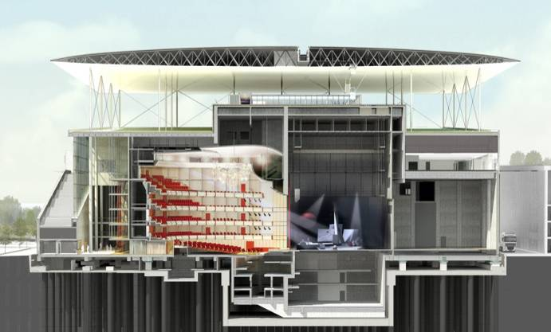Introduction

In terms of the construction of Stavros Niarchos foundation Cultural center, is one of the most innovative projects ever made, the 10.000m2 ferrocement canopy. The Opera’s canopy is consisted of 716 ferrocement panels, the construction of each requires high standards in terms of accuracy. To catch these high accuracy standards the panels are examined both in terms of geometric verification and quality control.

**Pre-construction phases of panel**

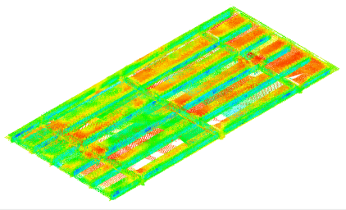The following procedures were ​​necessary for constructing the panels within the required accuracies and specifications.

* Deflections to be given on the steel formwork specified according to the unique shop drawing for each panel.
* Surveying check to be performed on reinforcement during the positioning on the steel formwork.
* Surveying checks to be performed on side moulds before the beams and ribs casting.
* Creation of control points on the panels to be used for positioning and transformations between coordinate systems.

**Required Equipment**

The requirements during the construction and checking of the panels are very high in terms of accuracy which cannot overpass the limit of 2mm.To catch these high standards, it was required

* Sokkia SDL30, a high accuracy digital leveler and the invar bar-coded rod.
* High accuracy Total Stations (Leica TS30, Sokkia NET1)
* Multi-Station MS50, for scanning the panels.

**As-built of anchors, couplers of panel and scanning**

After the construction of each panel the following procedures were necessary in order to certify the as-built situation.

* As-build surveying of anchors by usage of special item- 3 points for the definition of 3d vector of the anchor and the base of it.
* As-build surveying of coupler of each bracket in order to certify its position.
* Scanning of the constructed panel in order to certify the constructed geometry.

**Geometric verification of panel**

The geometric verification of the panel is performed by creating the 3d model of the panel. The geometric information is taken from the transverse and longitudinal sections at predetermined points. The requirements during the construction and checking of the panels are very high in terms of accuracy which cannot overpass the limit of 2mm.

The data examined for the geometric verification of each individual panel are:

* The distance between the ribs(Vertical Beams).
* The deviations of Ribs axes.
* The width of the ribs.
* The distance between the Beams.
* The deviations of Beams axes
* The width of the Beams
* The Flange Thickness

